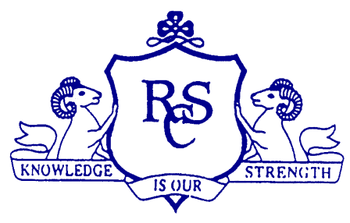
Transition Unit Ramsgrange Community School
Teacher Names: Dated:

- Title of Transition Unit
- Area of Study
- Overview
- Related Learning

- Summary Outline

- Breakdown of the Unit
Timetable Periods

- Aims

- Learning Outcomes
On completion of this transition unit the student should be able to:-

- Key Skills
Key Skills | Evidenced by
Being Personally Effective
Information Processing
Critical & Creative Thinking
Communicating
Working with Others

- Teaching Approaches
- Assessment Approaches
- Evaluation
- Resources

