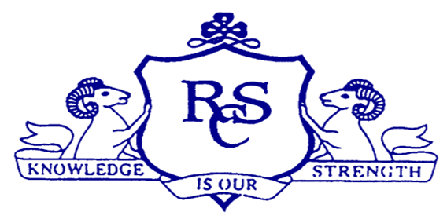

**RCS Open Night**

**Information 2016/2017**

***Introduction***

Ramsgrange Community School resulted from the amalgamation in 1977 of Shielbaggan Vocational School and St Louis Secondary School. Ramsgrange Community School is a co-educational, multi-denominational school. Our school ethos centers on respect for oneself and for others and on love of our religious and cultural heritage, both as Irish citizens and Europeans.

As a Community School we aim to provide quality education for the people of the area which we serve. We offer a comprehensive range of subjects at both junior and senior level as well as P.L.C. courses and Adult Night Classes. The school is very proud of its pupils both past and present, its history, tradition and past achievements.

We recognise the immense contribution of the Trustees who are the St Louis Sisters and Waterford and Wexford Education and training board, teaching

Staff, Students, Parents and the local community in bringing the school to the forefront of educational and sporting achievements in the county.

The school is managed by a Board of Management consisting of three St Louis Sister nominees, three Waterford and Wexford Education and training board nominees, two Parent nominees, two Teacher nominees and the Principal as secretary.

Ramsgrange Community School is very conscious of current educational reform and change. We are committed to embracing new thoughts and processes and we will continue to be key players in educational debate and innovation for the greater good of all our stakeholders.

Our school is an exciting place to belong as we reach our 40 year milestone next year!

**Our Vision**

***Ramsgrange Community School***

***Respect, Community, Success***

***Enrolment Evening***

***Wednesday October 26th 6pm-8pm***

***Entrance Assessment***

***Saturday February 4th 2017 –* 9.30am to 1pm**

**Mission Statement**

***Ramsgrange Community School is a welcoming, open and inclusive school.***

***Our aim is to develop each of our students as a whole person by promoting an atmosphere of respect, honesty and fairness in which all in the school community can achieve their full potential***

***We are part of the D.E.I.S Programme (Delivering Equality of Opportunity in School)***

This is a *Department of Education and Skills* programme offering extra resources and support to schools.

These include:

1. A dedicated full time **Home School Liaison Coordinator**.
2. A dedicated full time **Career Guidance Teacher**.
3. A dedicated full time **School Chaplain.**
4. Support from the Department of Social and Family Affairs for the provision of meals to our students. Each Student is **subsidised €2 daily** for school meals.
5. **Breakfast Club** – consisting of tea and toast is available free of charge to **all** students from 8:00am until 8:55am each day
6. School Completion Programme – Provides an Induction Programme to our 1st years and a **Project Worker** to the school
7. **Book Grants** – each eligible first year receives a subsidy towards the cost of books each year.
8. **Mentoring Programme** – when the student gets his/her place in college.

***Our students are in a very safe environment while in the school.***

***They are supervised from the time they arrive in the school until they leave again. They remain in school during all breaks.***

***Student Support System***

Pastoral Care is an integral part of the holistic education offered by us. The aim of Pastoral Care is to ensure that our school is primarily a caring community.

The Principal, Ms. Rachel O’Connor, and Deputy Principal, Ms. Tracey Edwards, are committed to supporting all our students through our pastoral care system. This consists of;

1. ***Chaplain***

Our School Chaplain, Ms. Marie McCabe, is in a unique position to assist the pastoral care system within our school. The Chaplain works with staff in providing spiritual and pastoral care to the whole school community.

1. ***Guidance Counseling Department***

Ramsgrange Community School Guidance Department provides a full range of services including Vocational/Educational Guidance, Personal Development/Counseling, Aptitude/Intelligence testing. The Career Guidance Counsellor, Ms. Mary Harris, is available to meet students in class groups and for individual consultation on matters relating to career advice and personal difficulties.

Our staff has a great concern for the well-being of our students. Out of this concern, staff members may refer students to the Guidance Counsellor. These meetings are confidential within the parameters of Child Protection Guidelines.

1. ***Home, School, Community Liaison Coordinator***

Ms. Ann Cadogan is our Home School Community Liaison Coordinator.

Ms. Cadogan works to strengthen the links between parents and the school. She develops partnerships with the local community which helps in promoting the educational interests of students. Courses are provided for parents on personal development and educational development as well as leisure activities. Home visits are an essential part of the work where parents have the opportunity to chat about concerns and aspirations alike. There is now a parents’ room in the foyer where parents are welcome to drop in for a coffee and a chat as well as getting info on courses and local services.

***School Structure***

1. ***Classroom Teacher***

Classroom teachers are the primary educators of your child in Ramsgrange Community School. Through their daily interactions our teachers strive to build positive working and learning relationships with each student. Our teachers work to help each student reach their personal academic potential while ensuring they have the necessary supports to grow and mature into responsible young men and women of the future.

1. ***Class Tutor***

The Class Tutor takes particular care of one class group. He/she engenders a supportive, positive atmosphere in which success and achievement are highlighted and valued. He/she liaises with class teachers and Year Heads.

1. ***Year Head***

Year Heads play a major role in the care and support of our students in addition to their disciplinary role.

***Opportunities for peer support***

1. ***Meitheal Leaders***

This is a peer-support, anti-bullying Programme run by our 6th years to help our 1st years. The Meitheal leaders are 6th year students selected through interviews with the Wexford Meitheal Alliance at the end of 5th year. During their summer holidays those selected spend a week, along with leaders from other Wexford schools, training to deal with situations that might arise at school.

The Programme aims to tackle difficulties at an early stage, to build self-confidence and a sense of responsibility for others. Meitheal aims to make school a better place in which to belong.

1. ***Student Council***

The Student Council provides a forum for students to voice their opinions and make recommendations in connection with the running of the school. It gives students and staff an opportunity to develop a working relationship that benefits all concerned.

1. ***Rainbows***

‘Rainbows’ is a student support Programme, which has been set up to help students who have experienced personal loss, through the death of a loved one or through the separation of parents. At small group meetings, facilitated by teachers, students get an opportunity to share their experience with others and work through some of the unresolved anxieties, associated with their loss.

1. ***Senior Prefects***

This presents an opportunity for students to take personal responsibility for many of the day-to-day activities of school life. This allows peer leadership to be developed and established within our student body.

***Homework Supports***

***Supervised Study***

A Programme of supervised study is available to all students, four evenings per week – this is run as a Private Enterprise by two members of the Teaching staff.

***Homework Club***

This is a Programme to help students who need assistance with their

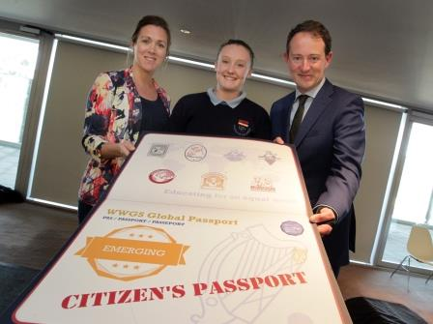homework; small groups are assisted by qualified personnel. Homework Club is run both at lunchtime and after school. This is free of charge to our Students.

One of only 20 schools in the country to receive a Global Citizen Passport this year!

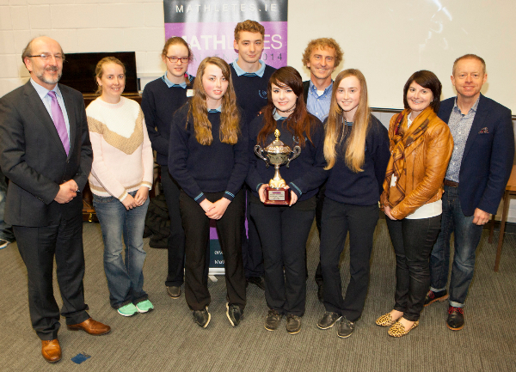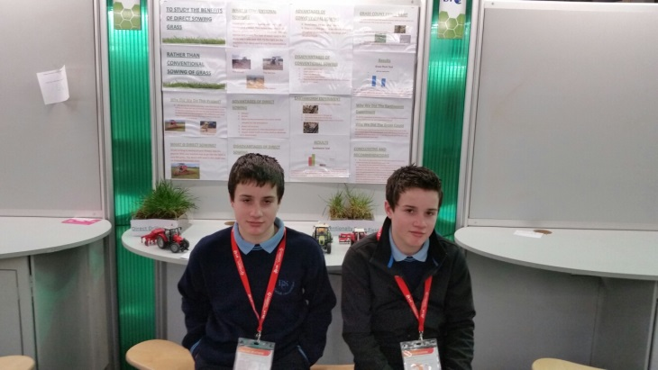

MATHlete’s with the Khan Academy – RCS were ALL IRELAND CHAMpions in 2015

The ONLY school to represent Wexford in the BT Young Scientist this in 2015

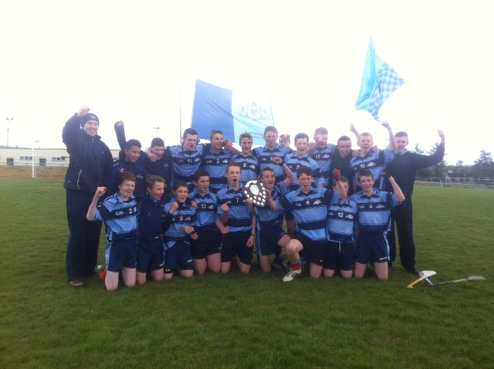

Leinster Champions!!!!

**SENIOR CYCLE EDUCATIONAL PROGRAMME**

|  |  |  |  |  |  |  |  |
| --- | --- | --- | --- | --- | --- | --- | --- |
|  | | **LEAVING CERTIFICATE** | | | | | |
|  | | | | |  | | | |
| **A wide range of subjects are studied in preparation for the Leaving Certificate examination.** | | | | | | | | |
|  | | | | |  | | | |
|  |  | | | | |  | | |
| **CORE SUBJECTS** | | |  | **OPTIONAL SUBJECTS** | | | | |
| * **Irish** * **English** * **Mathematics** * **Religion** * **Physical Education** * **Guidance** | | | * **Art** * **French** * **German** * **Biology** * **Chemistry** * **Agricultural**   **Science**   * **Business** * **Accounting** * **Home Economics** | | | * **Economics** * **Geography** * **History** * **Engineering** * **Construction**   **Studies (Wood)**   * **Design &**   **Communication**  **Graphics** | |
|  | | |

|  |
| --- |
| **Leaving Certificate Vocational Programme**  **The LCVP module is undertaken as an additional module by the majority of our Leaving Certificate students. They study enterprise, preparation for work, work experience and information technology.** |

|  |  |
| --- | --- |
| **Transition Year** | **Leaving Certificate Applied** |
| Any student entering Senior Cycle may take Transition Year as an integral part of a six year educational programme.  In devising this programme, the school has at all times borne in mind that the primary purpose of the year is to allow students time to mature and develop their self-esteem. More info: **www.ty.slss.ie** | LCA is designed for those students who do not wish to proceed directly to 3rd level education or for those whose needs, aspirations and aptitudes are not adequately catered for by the traditional leaving certificate.  More info: **www.lca.slss.ie** |

|  |  |
| --- | --- |
| **Post Leaving Certificate Programme** | |
| QQI | 3 QQI one year Level 5 PLC courses are currently offered. Business/ Computers, Business/Admin & Sport, Leisure & Recreation |

**JUNIOR CYCLE EDUCATIONAL PROGRAMME**

|  |  |  |  |  |
| --- | --- | --- | --- | --- |
|  | **JUNIOR CERTIFICATE** | | | |
|  | | |  | | |
| **A wide range of subjects are studied in MIXED ABILITY CLASS GROUPS.** | | | | | |
|  | | |  | | |
|  |  | | | |  |
| **CORE SUBJECTS** | |  | | **OPTIONAL SUBJECTS** | |
| * **Irish** * **English** * **Mathematics** * **Geography** * **History** * **Religion** * **Physical Education** * **CSPE** * **SPHE** | | * **Art** * **French/ German\*** * **Music** * **Science** * **Wood Work** * **Business Studies** * **Metalwork** * **Home Economics** * **Technical Graphics** * **Computers** | |

|  |  |
| --- | --- |
|  | **Junior Certificate Schools Programme**  **Learning supports are made available to some Junior Certificate students through JCSP.**  **This programme sets short term attainable targets I order to help build students confidence.** |

***Co-Curricular and Extra Curricular Activities***

******In Ramsgrange Community School, our aim is to promote the spiritual, intellectual, social, personal and physical development of each individual student. Curricular and co-curricular activities foster this holistic education. Teachers give freely of their personal time to organise these activities.

The school has a proud tradition of competing in the Leinster schools and college’s hurling, camogie, ladies football and men’s football competitions, having won several Leinster Championships at various age categories. Many past pupils, both male and female, have gone on to represent Wexford in senior hurling and football at intercounty level and it is hoped to maintain and promote personal and physical development along with academic achievement.

A sample of the broad range of extra and co-curricular activities on offer is;

* Gaelic football
* Hurling
* Camogie
* Basketball
* Athletics
* Enterprise
* Soccer
* Handball
* Talent Shows
* Educational Tours and

Trips

* European Project
* Public Speaking
* Outdoor pursuits
* Chess club
* Social Clubs
* Film Making Club
* Various Subject Societies
* Science Club
* Badminton
* Homework Club
* Art Club
* Choir & Orchestra
* Robotics
* Coding – beginner, advanced, expert
* Linguistics Olympiad
* LearnStorm
* An Gaisce
* YSI………..

***Facilities***

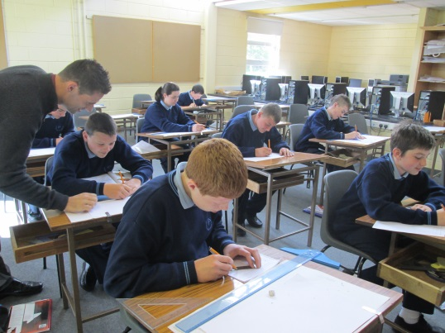

We are very proud of our school facilities which include;

* Fully equipped Gymnasium
* Material Technology – Woodwork Room
* Material Technology – Metalwork Room
* Design and Communication Graphics Room plus brand new suite of computers for same.
* Home Economics Room
* Food Studies Room

***A series of demonstrations by teachers and students will take place in all of these rooms on our open night.***

* Art, Craft, Design Room
* Demonstration Room
* Two Computer Rooms
* Science Suite
  + - * + Biology Lab
        + Chemistry Lab
        + Physics Lab
* Library
* Oratory
* Parents Room
* Stage
* Canteen

Our canteen offers healthy hot/cold food for pupils and staff. Food is available at breakfast, break times and snacks are available for study groups. The school offers subsidised food for students.

***Parents Association***

The school has a Parents Association, which maintains a close liaison with both staff and students. Two parent nominees sit on the Board of Management and are closely involved in the running of the school. Consultation with teachers is encouraged through regular Parent-Teacher Meetings.

Parent Volunteers are incredibly important here in RCS – Involvement of Parents has grown significantly over the last number of years – Initiatives that Parents are involved in include; Maths for Fun, Paired Reading, One Book One Community, Horticulture

A custom built room is available where parents may meet with our Home School Liaison Officer; Ms. Ann Cadogan. Parents are encouraged to drop into the school.

**School Policies**

A detailed list of school policies and information about our school is available from;

**Office:** 051389211

**Email:** Ramsgrange@eircom.net

**Web:** www.ramsgrangecommunityschool.ie

**Post:** Ramsgrange, New Ross, Co. Wexford

**Twitter**: @Ramsgrange_CS

**Enrolment**

**Enrolment Night will take place on Wednesday 26th October from 6pm– 8 pm. Enrolment forms are also available from our website under the Policies & Procedures tab on the homepage or by contacting the school office.**

**Please do not hesitate to contact me if I can be of assistance in clarifying any issues.**

**We look forward to meeting you.**

**Ms. Rachel O’Connor**

**Principal**

**Exam Facts & Statistics**

**Junior Certificate 2016**

Leaving Certificate Vocational Programme

***RCS appeared in the ‘Irish Tines’ in 2015 as FOURTH highest school in Co. Wexford out of 22 schools for Progession to 3rd Level***

**How transfer from Primary to Post Primary is managed.**

**Resource & Learning Support Teaching/Planning**

* Ann Cadogan & Aisling Foley visit all feeder Primary

schools in March/April to collect student transfer forms. They also meet with Principal/Class Teacher/Resource Teacher.

On confirmation of Enrolment the RCS confirms with the Primary School and we are sent the NCCA Educational Passport.

* Hours will be applied for where students needs deem it necessary

and are put in place for September of 1st Year. Students must be at or below the 2nd percentile in reading/maths in order to qualify for hours in the specific learning difficulty high incidence category. If they are not we will try to accommodate them with learning support hours.

* Entrance assessments are carried out in February prior to

starting in RCS in September. The Drumcondra Reasoning Test give a comprehensive overview of verbal reasoning, numerical ability and an overall score. Students also take the NGRT which will give a reading age.

* All of our current 1st year students have been tested in English

and Maths using the WRAT IV. The spelling and numeracy elements were administered

**All of this information is used to identify and target students with specific learning difficulties as early as possible.**

**Facts relating to current provisions**

# Behaviour System

**Our behavior system was introduced in 2012 and reviewed in 2015.**

**It is a model of best practice and has been reviewed by both staff and students.**

*The key to the success of this new system is that students have an opportunity to improve/modify their behaviour at all stages.*

**Cle**

Thank you for visiting us here in RCS!

If you have any questions, queries or comments please do not hesitate to contact me at the school,



Rachel O’ Connor, Principal