Principal: Rachel O’ Connor
Phone number: 051 389211
Fax: 051 389187
E mail: ramsgrange@eircom.net
Title of the project:
Focusing on Numeracy in Ramsgrange Community School
ALN Team
Rachel O’ Connor, Louise Walsh, Bridget Cadogan,
Objectives:

The focus of our evaluation is to identify and assess areas of numeracy in need of improvement thereby developing practical, implementable and effective whole-school strategies which will enhance our students overall proficiency in areas of numeracy as identified by the data.

Rationale for Project:
- As part of the PISA 2009 study our students ‘Mathematical Achievements’ indicated weaknesses when compared with results across Ireland.
- In March 2012 RCS was involved in St Patricks Education Centre Field Trial of standardised tests. Our Second Year students (current 3rd Years 2012-13) under performed in numeracy.
This led to our teacher focus as outlined below.

Initial Actions Taken:
Data Gathering from Staff:
- In August 2012 our teachers with the assistance of our Numeracy Link person and the Acting Deputy Principal, a facilitator with NIPT delivered and led a teacher focus in the area of Numeracy. From this focus group the following key areas or focus were identified; Literacy for Numeracy, Percentage calculations and Data Analysis and presentation.

Data Gathering from Students:
- The STen Scores from a representative sample of current 1st year students (2012-13) were established using the Drumcondra Reasoning Tests (Numeracy element) and correlated with national figures indicating no significant differences.
- A Criterion Referenced Maths competency test for current 1st Years (2012-13) was re-designed by and administered by the Principal in January which identified scope for improvement in the mastery of a range of specific skills in the cohort sampled. This analysis highlights the following areas for our initial focus on numeracy; Percentages. Data tables/interpretation. Problem solving (literacy for numeracy) Fractions
- Leaving and Junior Certificate exams results were also analysed over the last year and compared against national averages as data allowing for comparison with performance by other DEIS schools, with similar contextual factors, is not available.

Data Gathering from Parents:
- A survey of the 1st and 2nd Year parents (2012/2013) was carried out giving an insight into parent perception of their own ability at maths and their confidence levels in assisting their child with numeracy work and also gave insight into student habits in seeking assistance from parents with maths homework.

Strategies Implemented:
  - Following teacher focus a standard cross curricular approach to the key areas identified above were agreed and delivered which involved common agreed teaching methodologies from all teachers in all subject areas and agreed physical displays in all classrooms to support literacy for numeracy
  - Attitudinal surveys were administered in December 2012 to assess progress to date which showed the following:
    - Percentages: 77.65% of students across RCS believe that their ability to work out percentages has improved since September while the quantitative evidence suggests that 77.68% of students could work out a percentage problem. 94% of teachers said they agree/strongly agree that they have observed an improvement in students’ ability to work out percentages.
    - Data Presentation & Analysis: 78.57% could interpret data from a bar chart while 77.68% of students either agreed or strongly agreed that their ability to draw and interpret data using bar charts has improved. 33.3% of teachers agree that they have observed an improvement in student ability to draw and interpret data using bar charts.
    - Literacy for Numeracy: 79.57% of students believe that they are more aware of numeracy key words in their subjects while only 13.39% could identify new key words relating to numeracy. However, 83% of teachers agree/strongly agree that they have observed increased awareness of numeracy key words in their subject area.
  - ALN work formed basis for School Self Evaluation and following staff meeting School Improvement Plan with 4 key targets were established in relation to numeracy for 2013/2014.

Supports & Resources Accessed
Student Journal: Tracking my Test Score
- NIPT Workshop on Numeracy
- PDST support
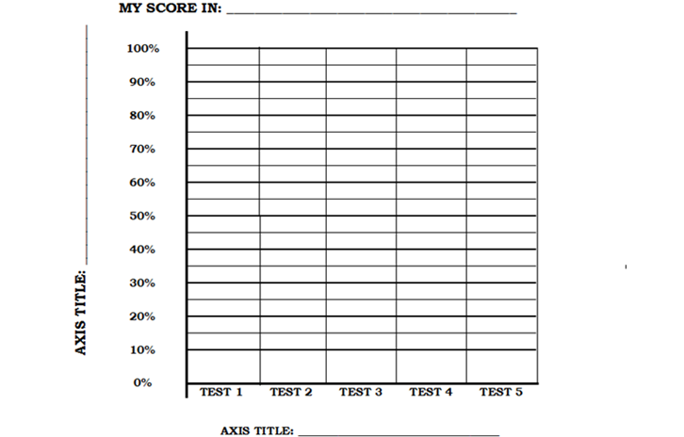
- National Strategy to improve Literacy and Numeracy.
- Time for meetings – working staff.
- Class teaching time.
- Criterion Referenced Test.
- Questionnaires for students, parents, teachers
- Subject Planning Meetings.

Challenges Faced
Data Gathering and analysis of same was very time consuming
Testing students and ensuring accurate results.
Meeting time
On-going monitoring and reviewing of progress and actions being taken

