TL21 – Literacy in Project Maths
Year 1 Summary
What has been done so far?
Student Attitudinal Survey – AP/TE
Maths Exam – Maths Department – BC/ NC/ TmcD/ JM/ CD Analysis by CB
Word –A-Day – English Department – SmcD/ OK/ SW/ BH / DOD – delivered by ALL Staff
Parent Attitudinal Survey – AC/MH/MC
Entrance Assessments – MH
Vehicle for improving student engagement in learning – SCP - incomplete
JCSP – Extra Maths Classes
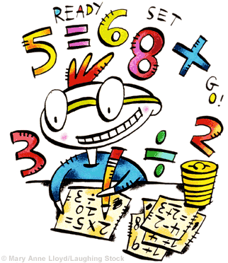
HSCL – Catch Up Maths initiative, Maths for Fun initiative and Paired Reading
Literacy in Project Maths Workshops – ROC & TE
What are we covering?
The Maths Teachers identified 25 keys words most commonly used in Project Maths. Over the next 5 classes, students will engage in activities (focusing on good group work practice – Think, Pair, Share model) that focus on those 25 key words.
Students will be re-tested following the 5 weeks, that should show an improvement in their understanding and application of these 25 key words.
1 Maths class is being used as a control group.
Results and Achievements so far!!!
- Full Staff involvement has really paid off – Thank you!
- 71% of 1st now say that they understand most of the words used in Maths
- 53% say that there are still other words that they don’t understand – these are words like ‘evaluate, deduce, consider’

- 1C- their test results improved by a 38%
- 1C – their test results improved by 26%
- 1B – their test results improved by 10% (these are the control group who were NOT involved)
A big sincere thank you to EVERYONE, the results prove that these initiatives do work. I look forward to a further strive for improvement next year! Rachel.

