TL21 – Literacy in Project Maths
March Update
What has been done so far?
Student Attitudinal Survey – AP/TE
Maths Exam – Maths Department – BC/ NC/ TmcD/ JM/ CD Analysis by CB
Word –A-Day – English Department – SmcD/ OK/ SW/ BH / DOD – delivered by ALL Staff
Parent Attitudinal Survey – AC/MH/MC
Entrance Assessments – MH
Vehicle for improving student engagement in learning – SCP
JCSP – Extra Maths Classes
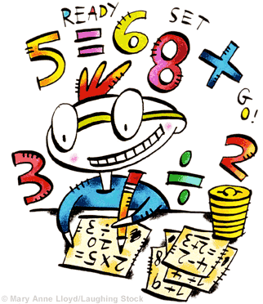
HSCL – Catch Up Maths initiative, Maths for Fun initiative and Paired Reading
March – April: What’s the next step? Who?
ROC & TE
Who are we working with?
2 First year Maths Classes
What are we doing?
5 workshops (1 class per week)
What are we covering?
The Maths Teachers identified 25 keys words most commonly used in Project Maths. Over the next 5 classes, students will engage in activities (focusing on good group work practice – Think, Pair, Share model) that focus on those 25 key words.
Students will be re-tested following the 5 weeks, that should show an improvement in their understanding and application of these 25 key words.
1 Maths class is being used as a control group.
Next TL21 Workshop in Co. Wexford Ed. Centre is Wednesday March 19th.

