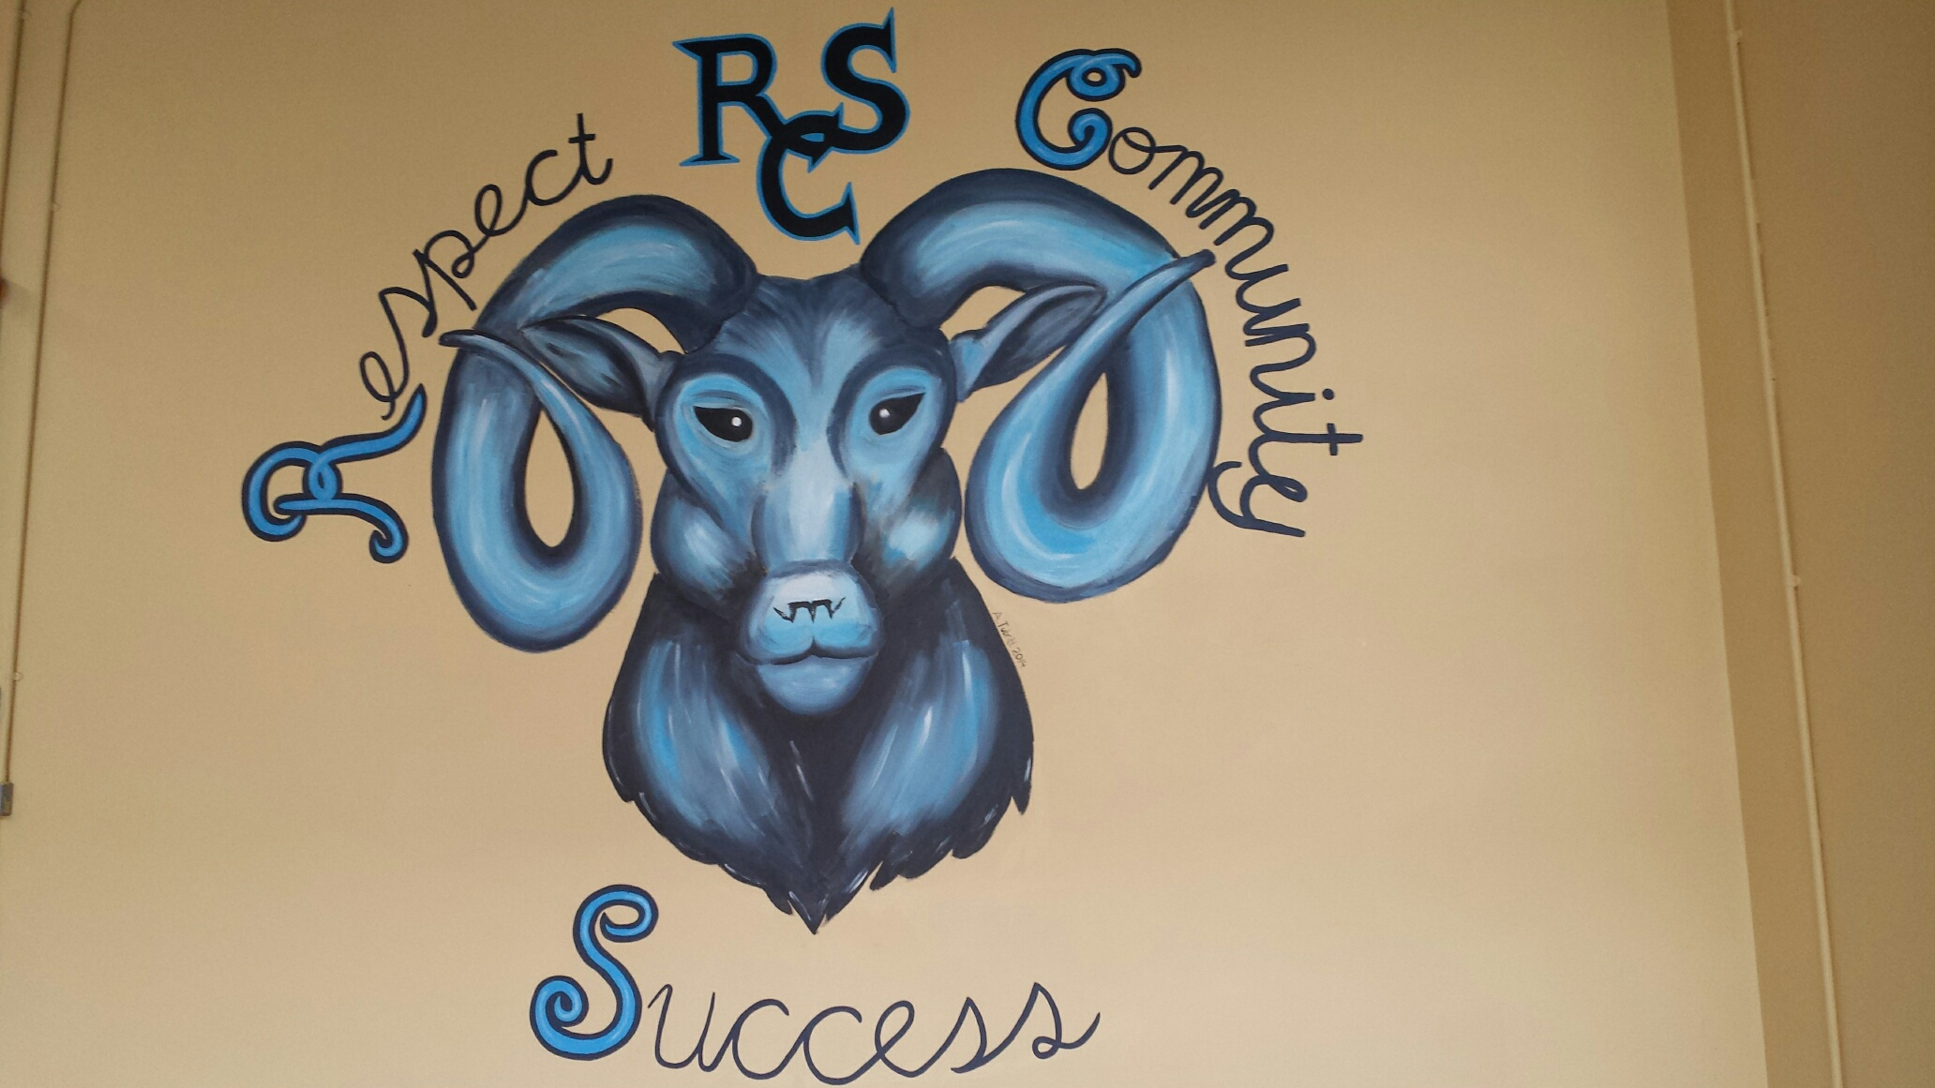

Ramsgrange Community School

2015/2017

Subject/Department Plan – organisation and development in the pursuit of enhanced teaching and learning

Subject/Department:

Contents

Section | Heading | Page
1 | School Mission Statement
2 | Programme and Levels
3 | Subject/Department Aims
4 | Subject/Department Objectives
5 | Subject Liaison Teacher and Subject Teachers
6 | Time Allocation
7 | Grouping of Students – Mixed Ability/Streaming
8 | Special Arrangements for Mixed Ability Teaching – details
9 | Student Access to Subject/Level
10 | Class Organisation
11 | Strategies for Classroom Behaviour Management
12 | Textbooks and Course Materials
13 | Planning for Students with Special Needs
14 | Cross-Curricular Planning
15 | Subject/Department Planning for a Culturally Diverse Society
16 | Effective Teaching Methodologies
17 | Student Engagement in Learning
18 | Range and Variety of Resources
19 | Use of ICT Facilities
20 | Provision for Health and Safety Requirements
21 | Curriculum Content: 1st year
22 | Curriculum Content: 2nd year
23 | Curriculum Content: 3rd year
24 | Curriculum Content: 4th year
25 | Curriculum Content: 5th year
26 | Curriculum Content: 6th year
27 | Homework Procedures
28 | Assessment and Examination Procedures
29 | Arrangements for Formative Assessment
30 | Literacy – School Improvement Plan
31 | Numeracy – School Improvement Plan
32 | Record-Keeping Procedures
33 | Reporting Procedures
34 | In-Class Career Guidance Provision for Subject/Department
35 | Teacher In-Career Development
36 | DES Subject/Department Inspection
37 | Analysis of State Examination Results
38 | Analysis of Subject’s/Department’s Strengths and Weaknesses
39 | Subject/Department Action Plan, including Self-Evaluation Tools
40 | Subject Department Meeting Agendas
41 | Development Education

1. School Mission Statement & Vision:

Ramsgrange Community School is a welcoming, open and inclusive school. Our aim is to develop each of our students as a whole person by promoting an atmosphere of respect, honesty and fairness in which all the school community can achieve their full potential.

RCS Vision: Respect, Community, Success

2. Programmes and Levels:

3. Subject/Department Aims:

4. Subject/Department Objectives:

5. Subject Liaison Teacher and Subject Teachers:

Liaison Teacher:

Subject Teachers:

Teacher | Qualifications

6. Time Allocation:

7. Grouping of Students (Mixed ability, Streaming):

8. Special arrangements for mixed ability teaching - details:

9. Student Access to Subject / Level:

10. Class Organisation:

11. Strategies for Classroom Behaviour Management:

12. Textbooks and Course Materials:

Year | Textbooks | Course Materials
1st

2nd

3rd

Transition Year

5th

6th

13. Planning for Students with Special Needs:

14. Cross-Curricular Planning:

15. Subject/Department Planning for a Culturally Diverse Society:

16. Effective Teaching Methodologies:
Please STATE ‘YES’ ‘No’ or ‘In Progress’ after each statement and state the evidence for this judgement.

Statement | Yes/No/In progress | Evidence
Lessons are guided by curriculum-linked learning outcomes that are shared with the students

Expected learning outcomes are achieved during lessons

Attention is given to the consolidation of student learning during and at the end of the lesson

Attention is given within each curriculum area
- to the systematic development and application of knowledge and skills, including the students’ literacy, numeracy and ICT skills.

- to the development of positive dispositions and attitudes towards learning

A range of curriculum-appropriate approaches are used including
- Guided discussion
- Collaborative and co-operative learning
- Investigative approaches to learning
- Higher-order thinking and problem solving
- Encouragement of the student’s personal and creative response to the subject
- Developmentally appropriate reference to requirements for state examinations

Opportunities for collaborative and independent work are provided

Students’ prior learning, interests and experiences are taken into account in lesson organisation and content

Appropriate links to other subjects are established and exploited with particular reference to cross-curricular opportunities to support students’ literacy and numeracy skills

Questions are clear, include lower-order and higher-order questions and stimulate student response

Questions are equitably distributed among the students

There is effective differentiation to cater for the range of students’ abilities

Students are enabled to use relevant and necessary resources (including ICT) to support their learning

Assessment for learning is embedded in classroom practice (sharing learning intention with students, establishing evaluation criteria, feedback)

Assessment outcomes are systematically analysed and used to inform subsequent learning experiences for students

17. Student Engagement in Learning:

Please state ‘Yes’, ‘No’ or ‘In Progress’ after each statement and state the evidence for this judgement.

Statement | Yes/No/In progress | Evidence
The students are enabled to engage actively in their learning
  - Students work purposefully during lessons
  - Students are interested in the lesson content
  - All students participate in the lesson
  - There is a balance between teacher talk and student talk
  - Opportunities are provided for students to report on and explain their learning

Students are given purposeful and frequent opportunities to engage in collaborative learning

Students are given purposeful and frequent opportunities to engage in independent learning

The students are enabled to develop appropriate subject-specific skills in a progressive and sequential way

The students engage in relevant co-curricular activities

The students engage in relevant extra-curricular learning experiences

The students are adequately challenged in their learning

The students are adequately supported in their learning

Students enjoy their learning and are motivated to learn

Students achieve the expected learning outcomes of lessons

18. Range / Variety of Resources:

19. Use of ICT Facilities:

20. Provision for Health and Safety Requirements:

The Department has access to the school’s Health and Safety Noticeboard in the Staff Room and access to the H&S Committee as necessary.

21. Curriculum Content: 1st year

22. Curriculum Content: 2nd year

23. Curriculum Content: 3rd year

24. Curriculum Content: 4th year

25. Curriculum Content: 5th year

26. Curriculum Content: 6th year

27. Homework Procedures:

28. Assessments and Examinations Procedures:

29. Arrangements for Formative Assessment:

30. Literacy – School Improvement Plan (May 2015)

Set out the steps being taken by the Department to meet the targets set in the School Improvement Plan, as follows:

Target 1:

Steps:

Target 2:

Steps:

Target 3:

Steps:

31. Numeracy – School Improvement Plan (May 2015)

Set out the steps being taken by the Department to meet the targets set in the School Improvement Plan, as follows:

Target 1: To increase the proportion of students taking higher level Maths at Junior Certificate from 30% to 35% by 2014 and to 38% by 2015.

Steps:

Target 2: To increase the 2012/2013 1st year cohorts ability to gather and analyse data from 78% to 83% by the end of Yr 2 and 100% by the end of Yr 3

Steps:

Target 3: All of 2012/2013 1st Yr student cohort will have a visual awareness of what percnetages look like as part of a whole. All Students should be able to convert their test results from fractions to percentages by Christmas.

Steps:

Target 4: 80% of 2012/2013 1st Yr student cohort will have knowledge of basic numeracy terminology e.g. solve, simplify, analyse, compare, the sum of…. By the end of 2013/2014 and this will increase to 95% by 2014/2015 (21% at beginning of 2012/2013)

Steps:

32. Record Keeping Procedures:

33. Reporting Procedures to Parents:

34. In-class Career Guidance Provision for this Subject/Department:

35. Teacher Continuous Professional Development in the past 6 years:

2013-14:
Name | Date | Topic

2012-13:
Name | Date | Topic

2011-12:
Name | Date | Topic

2010-11:
Name | Date | Topic

2009-10:
Name | Date | Topic

36. DES Subject/Department Inspection:

Date:

Recommendations:

Steps taken to address recommendations:

37. Analysis of 2015 State examination results:

Junior Certificate

Comment on the school’s results in this subject in comparison to national outcomes at different levels.
Answer:
Outline steps to be taken in 2015/2016 to build upon any strengths identified by this comparison.
Answer:
Outline steps to be taken in 2015/2016 to build upon any weaknesses identified by this comparison.
Answer:

Leaving Certificate

Comment on the school’s results in this subject in comparison to national outcomes at different levels.
Answer:
Outline steps to be taken in 2015/2016 to build upon any strengths identified by this comparison.
Answer:
Outline steps to be taken in 2015/2016 to build upon any weaknesses identified by this comparison.
Answer:

38. Subject’s/Department’s Self-Evaluation: Strengths and Weaknesses

Strengths | Evidence

Weaknesses | Evidence

39. Subject/Department Action Plan 2015/2016

Outline the measures to be taken over the next year , by whom and when to address the weaknesses and build upon the strengths identified in the previous section. Please refer to specific action/support, if any, required from school management.

Measure | By whom? | When?

40. Subject Department Meeting Agendas

August 2015

Appointment of Subject Liaison Teacher
Review of Leaving Certificate 2015 results
Department business

October 2015

Review of Junior Certificate 2015 results
Subject Department Plan
Department business

December 2015

Subject Department Plan –
Department business

April 2016

Budget submission, 2016/2017
Booklists, 2016/2017
Subject Department Plan
Department business

41. Development Education

Development Education is an educational process aimed at increasing awareness and understanding of the rapidly changing, interdependent and unequal world in which we live.
Development Education seeks to engage people in analysis, reflection and action for local and global citizenship and participation.

Development Education is about supporting people in understanding and acting to transform the social, cultural, political and economic structures which affect their lives at personal, community, national and international levels

Please outline 3 ways in which Development Education is incorporated into your subject:
1.
2.
3.

*******************************************************************

Important

Please remember to submit a copy of the minutes of each subject department meeting to the Principal within one week of the meeting.

